Mini Project –
Time Series Forecasting Model

By Sakshi Jain

Table of Contents

- Project Objective

- Exploratory Data Analysis – Step by step approach
  - Descriptive Statistics
  - Missing Values
  - Visual interpretation

- Stationarity Test

- ARIMA Modelling & Forecasting
  - Manual ARIMA Model
  - Checking ACF & PACF
  - Auto ARIMA Model
  - Forecasting

- Conclusion

Project Objective

- The available data is Time series data for Australian monthly gas production between 1956 - Jan to 1995 - August

- The objective is to use analyse and build a time series model to forecast 12 periods in future
Exploratory Data Analysis
==================================================================================

- I have used the below mentioned libraries to complete my project & also to conclude something relevant out of my project
- library(ggplot2)
- library(tseries)
- library(forecast)

- This time series has total of 476 entries with monthly frequency. There were no missing values in the dataset.

- This is monthly time series with frequency of 12 observations per year

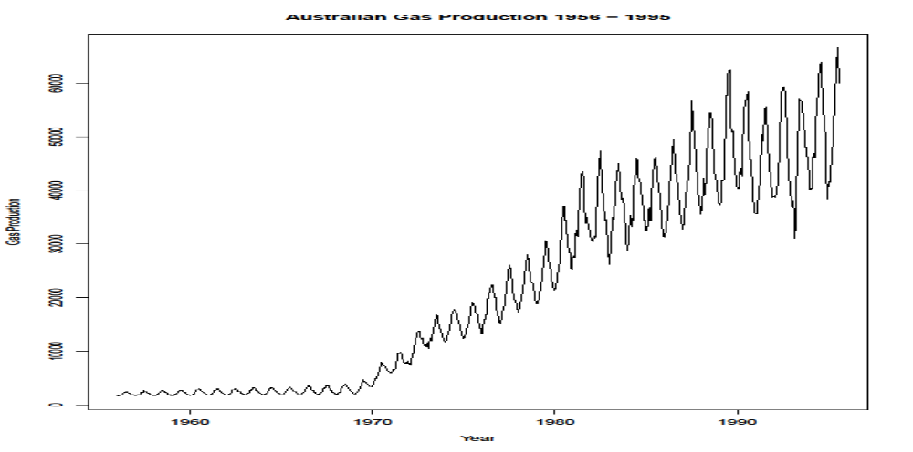

- Monthly gas production between 1956 to almost 1970 is flattened level

- Post 1970 era there is gradual increase in production i.e showing an upward trend with peaks and troughs indicating some seasonality in data

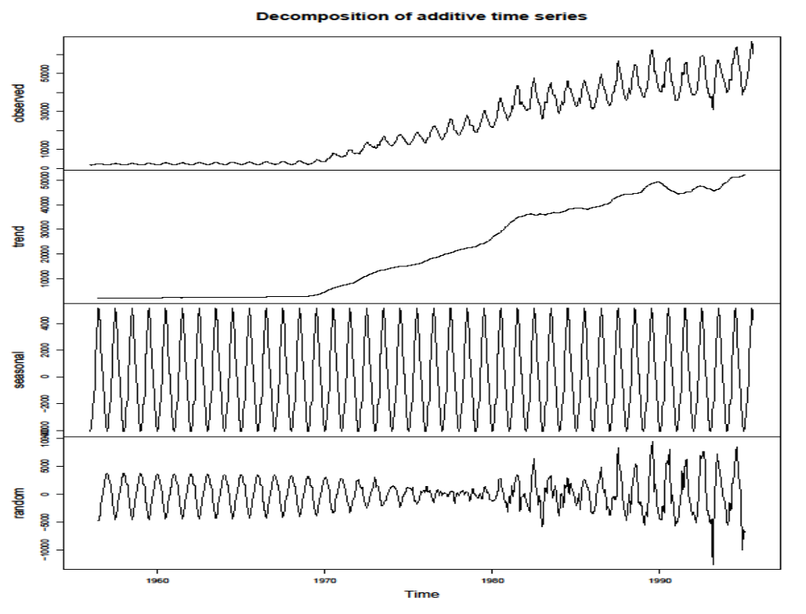

- Doing a additive decomposition of AU gas production dataset we observe
  - There is trend component taking upward route around 1970s
  - There is strong seasonal component
  - There is random component which shows constant variance till somewhere mid 1970s

Stationarity Test

- Visual observation of decomposed plot clearly tells us that since both trend and seasonality are present in this series hence it is Not Stationary
- Dicky Fuller test for Stationarity
- Null hypothesis Ho : Time series non-stationary
- Alternative hypothesis Ha : Time series is stationary
- The p-value = 0.2764
- Since p-value is much greater than significant value of 0.05 we fail to reject the Null Hypothesis Ho
- Time series AU.gas is not-stationary Time series AU.gas is not-stationary
- Since AU gas production data series is seasonal data it can be de-seasonalize by taking out the seasonal component of series

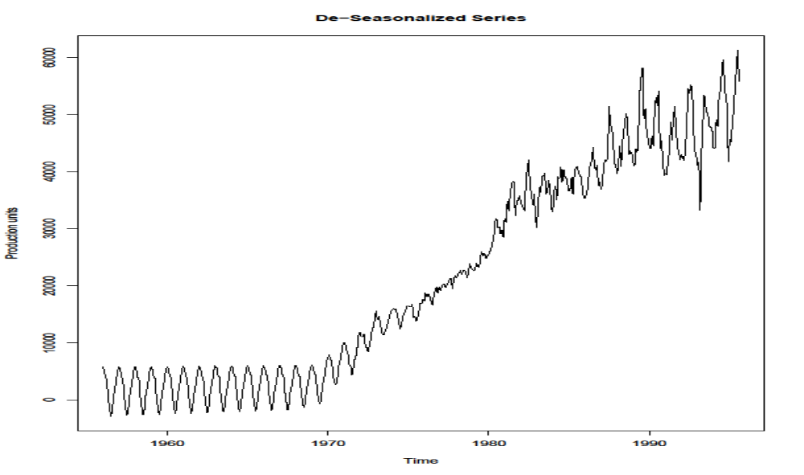
ARIMA Modelling & Forecasting

- We will first split the dataset into test & train dataset then we will have to stationarize the series which can be done by differencing
- We will again for Stationarity using adf.test
- The P-Value is 0.01. It has gone down significantly we can say that differenced series is stationary now
- Checking ACF and PACF

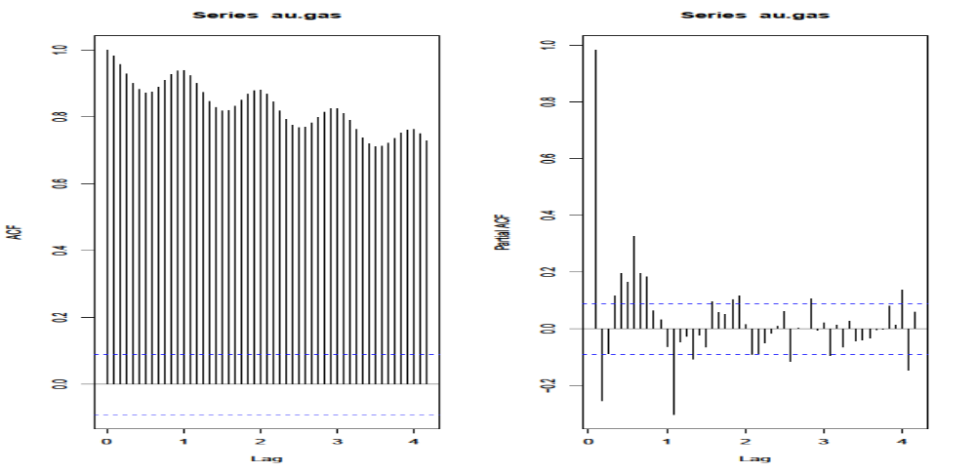

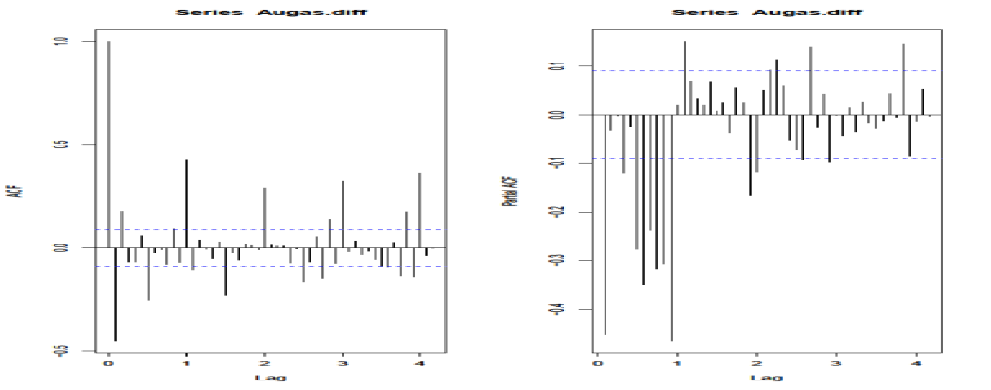
- We will first build Manual ARIMA Model. AIC is 7747.61 ; Lower is considered better
- Auto ARIMA Model: We let auto ARIMA decide on best parameters
- Forecasting the Model: For ARIMA model is assumed to be reasonable for a series, it is important to check whether the residuals are following white noise or not. Towards that goal Box-Ljung test is applied.
- Box-Ljung test: This checks whether the residuals of time series data are stationary or not.
    - H0: Residuals are stationary
    - H1: Residuals are not stationary
- We check on the accuracy of our manual ARIMA model on our test data i.e. test.AUgas Period from Jan-1994 to 1995 Aug.
- There is visible difference between modelled and actual values for the test period observations

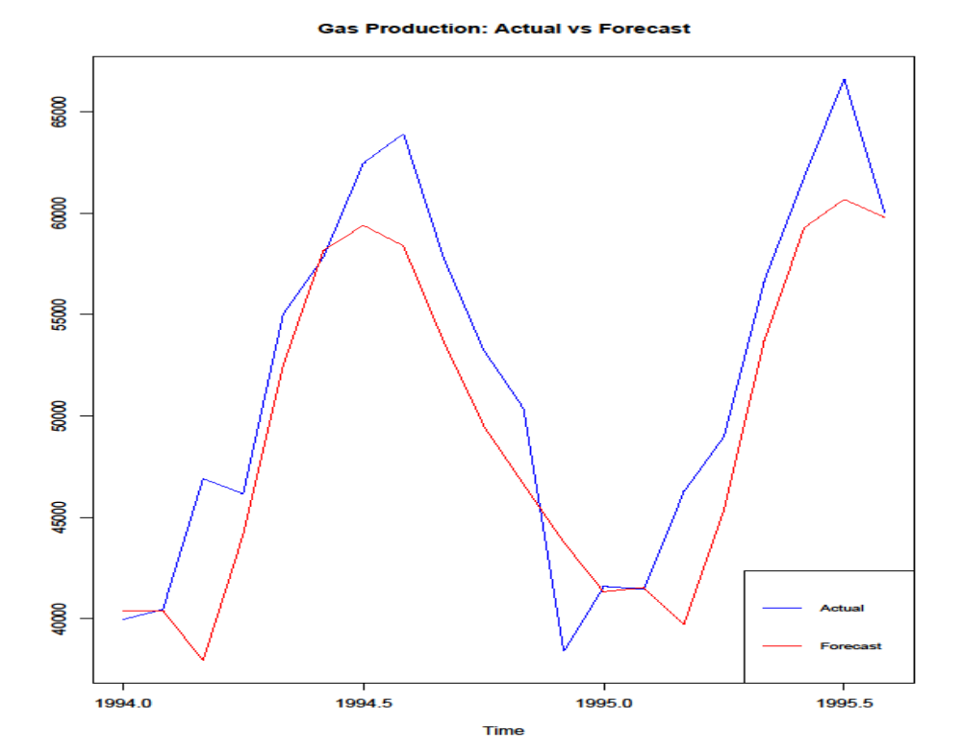

CONCLUSION

- We find that mostly the Manual Arima model is neck to neck in most of the accuracy parameters like
    - Root mean squared error
    - Mean absolute percentage error
- But when it comes to actual model based on AIC Auto arima performs better giving 7742 against manual models 7747
- We can improve model by dropping the long past observations and taking only the post 1970 era when a clear trend happens out

